
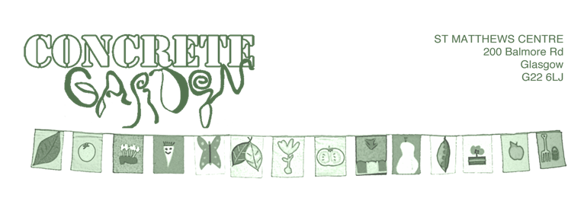
Job Title: Outdoor Play and Learning Youth Worker
Working pattern: 17.5hrs p/w
Monday/Tuesday/Thursday
(Term Time: After school, Holiday: Day sessions)
Rate of Pay: £13.45 p/h
Location: Back Garden, Possilpark, and as required
Responsible to: Outdoor Play and Learning Manager and Board of Trustees

Role
As a Play worker, you’ll be at the heart of creating a safe, welcoming, and imaginative space where children can explore, take risks, and lead their own play. You’ll work as part of a dedicated team to deliver outdoor play sessions that are inclusive, child-led, and rooted in freedom and fun!
Key Responsibilities
- Be a trusted and playful adult role model for children and young people.
- Support children to lead their own play, take safe risks, and explore freely.
- Deliver year-round play opportunities.
- Help manage and maintain a safe, fun, and inclusive outdoor play space.
- Promote positive behaviour and ensure all children feel safe and supported.
- Carry out dynamic risk assessments and uphold safety policies daily.
- Liaise with parents, carers, and partner organisations within our community.
- Support youth volunteering and leadership opportunities.
- Keep attendance records, complete daily evaluations, and help capture impact through observations, photos, and feedback.
- Assist with planning, setting up, and tidying away play sessions and activities.
- Specialist Areas of Play (Interests and experience)
- Free Play: Let children take the lead and shape their own play experiences.
- Food & Cookery: Plan menus with children, cook meals on-site, and deliver online cooking sessions for our daily snack.
- Building & Woodworking: Support safe, creative building projects and teach proper tool care.
- Creative & Imaginative Play: Encourage role play, storytelling, and performance to bring the play space to life.
- Bushcraft: Support children in exploring risky challenges such as bushcraft skills.
- Building: Den Building and Shelter building is a useful and practical skill to share within an outdoor setting.

About You
We’re looking for someone who is:
- Playful, kind, and reliable
- Confident working with children of all backgrounds and abilities
- Comfortable working outdoors
- Organised, proactive, and a great communicator
- Committed to equality, inclusion, and child safeguarding
- Experience in play work, youth work, childcare, education, or community work is a plus, but not essential. We first and foremost look for enthusiasm and commitment to children's right to play. Successful applicants must however be willing to work toward essential training and qualifications for the role.

Essential Criteria
- Genuine passion for play and child-led learning
- Proven experience (paid or voluntary) working with children
- Willingness to work evenings/weekends as needed
- PVG membership (or willingness to undergo PVG checks, which will be funded by the organisation)

Desirable (but not required)
- Basic First Aid Certificate
- Food Hygiene Certificate
- SVQ Level 2 in Youth or Play work (or working towards)
- Experience with diverse or vulnerable children
- Confidence in leading active games
- Familiarity with evaluation tools and digital platforms
- Gardening or interest in nature-based play

Other Requirements
- Willingness to work evenings and weekends as needed to support sessions and events
- A strong commitment to safeguarding and promoting the welfare of children and young people

What We Offer
- A creative, supportive team
- Ongoing training and development
- A chance to shape a unique community play space
- A meaningful role that makes a real difference

Our Commitment to Diversity, Equity, and Inclusion
At Concrete Garden, we believe that play is a universal right and a powerful tool for community building. We are committed to creating a space where every child, family, and team member feels seen, heard, and valued. Our play spaces are designed to be inclusive and welcoming to all, regardless of race, ethnicity, gender identity, sexual orientation, ability, socioeconomic background, or belief system.
We actively work to dismantle barriers to participation and strive to reflect the rich diversity of our community in everything we do, from our programming and partnerships to our hiring practices and volunteer opportunities. We recognise that inclusion is an ongoing journey, and we are dedicated to continuous learning and growth in this area.
We warmly welcome applicants from all backgrounds and lived experiences, especially those who have been historically underrepresented in play work and community development roles. If you share our passion for equity, creativity, and the transformative power of play, we’d love to hear from you

